KRITERIUM | TITEL/BEZEICHNUNG | LEHRPERSON/EN + KLASSE/N
B5 | COOL Assignment Doping | HASL, LHOT, 4SK
KURZBESCHREIBUNG DER AKTIVITÄTEN:
Ein fächerübergeifender COOL Auftrag mit den Fächern Englisch und Naturwissenschaften zum Thema „Sports and Doping“ wurde erstellt und mit der Klasse 4SK durchgeführt. Die Ergebnisse der einzelnen Aufgaben wurden in unterschiedlichen Gruppenzusammensetzungen in beiden Fächern inhaltsspezifisch präsentiert und diskutiert. Die Ergebnisse wurden in den Unterrichtsunterlagen festgehalten.

BEILAGE/N: (Screenshots, Dokumente, Bilder usw.)
Assignment: siehe ab nächster Seite

 | Klasse:  HAK IV | Fach/Fächer:  NAWI/ENWS |   Name:
Ausgabetermin:  Ausgabedatum wählen | Abgabetermin:  Abgabedatum wählen
Thema: Sports & Doping

Meine Lernziele: □ = zur Gänze erreicht | □ = weitgehend erreicht | □ = ansatzweise erreicht | □ = nicht erreicht
1. I can speak about values & cheating in sports and everyday life |  |  |  | □ □ □ □
2. I can explain different forms of doping |  |  |  | □ □ □ □
3. I have understood how different manipulations to enhance oxygen transport work |  |  |  | □ □ □ □
4. I can describe health risks arising from blood doping |  |  |  | □ □ □ □
5. I can summarize the topic in my own words |  |  |  | □ □ □ □
Aufgabenstellungen: |  |  |  | Sozialform  EA = Einzelarbeit  PA = Partnerarbeit  GA = Gruppenarbeit  ! = Pflichtaufgabe  + = Wahlaufgabe
SPORTS and DOPING  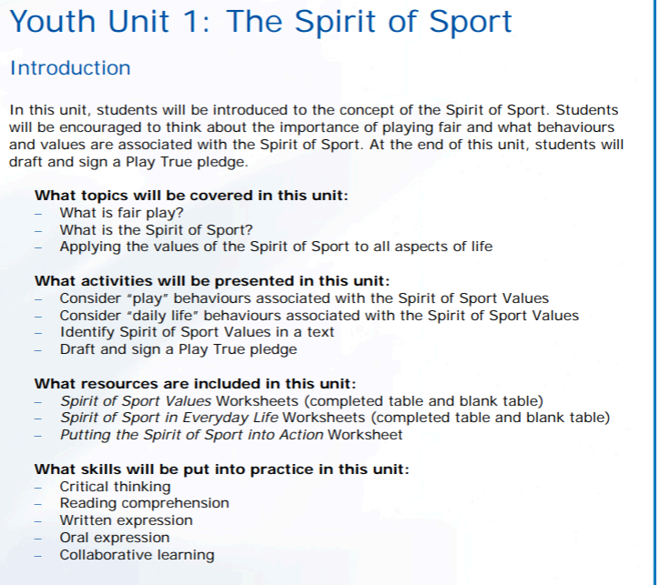  1) Work in pairs: Get together with a partner and give some thought to your very own definition of Fair Play and the Spirit of Sport.  2) Work in pairs: Find examples of Good Spirit of Sport Behaviour and Acts Contrary to the Spirit of Sport for all the listed Values on the worksheet below:  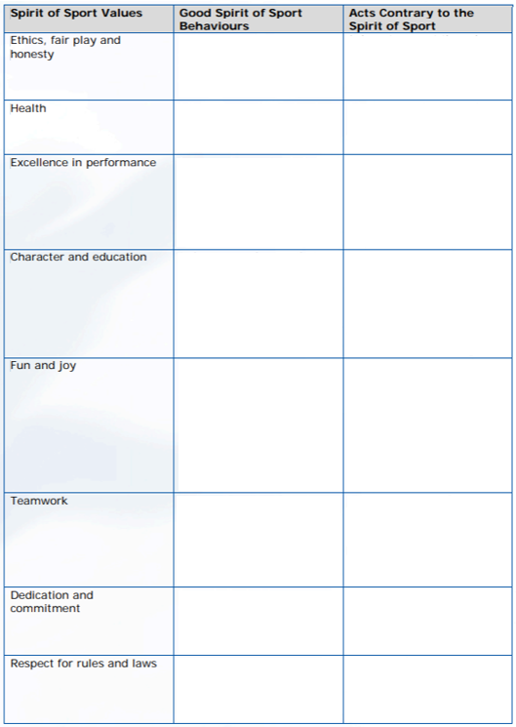  3) Disgraced sportsmen/sportswomen and the topic of cheating:  a) Groups of four: find an example of a person who has been caught cheating. Prepare a mini presentation in which you present the sportsman/-woman with the type of sports, the type of cheating and the consequences.  b) Work in pairs: Check out the link below, slide 3 and 4 and discuss the questions and situations with one partner. Be prepared to present the contents of your discussion.  https://skydrive.live.com/redir?resid=79CFF252BEEA0A7D!303&authkey=!ALG8a95Emk_-Qk4  4) Methods, Substances, Health Consequences, …  a) Work in pairs: Have a look at Fig. 1 „Components of Sports performance“. Colour and size of the circles symbolize type and significance of the different components in relation to the type of sports. Describe the differences.  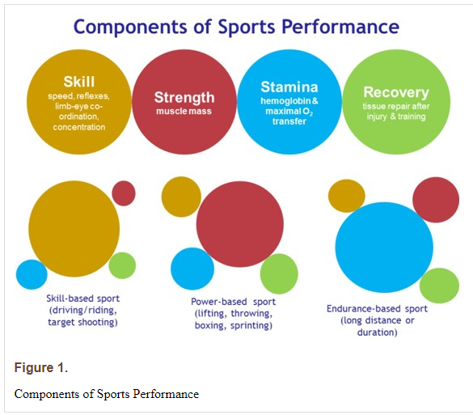  b) Work in pairs: Now have a look at Fig. 2 „Drugs that enhance sports performance“. Do a little research: Which of these drugs are hormones or at least belong to the endocrine system?  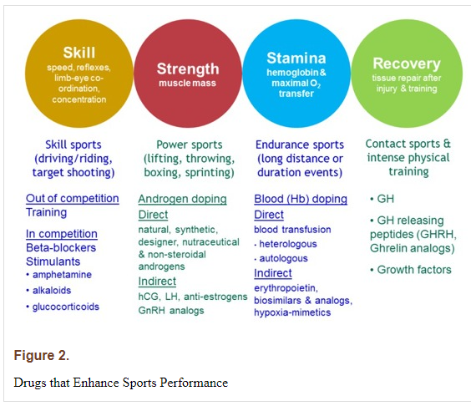  c) Individual work: Watch the short video (4:40 min) about the endocrine system and the relation between red blood cells and Erythropoietin (EPO). https://www.youtube.com/watch?v=PvuHB9XYENQ Write a short summary including information from the video only! Then find the German names for the glands described in the figure below.  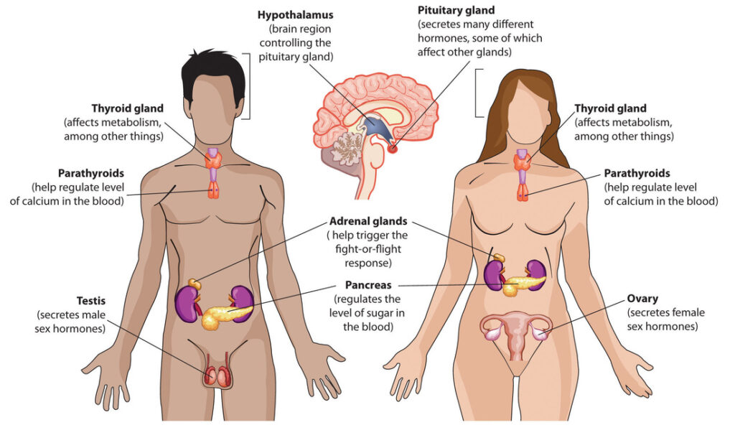  d) Work in pairs: analyze and compare Fig. 3 „Effect of Erythropoietin (EPO) on red blood cell (RBC) numbers“ and the short text below. Find missing information in both, the figure or in the text and mark and add the missing, relevant parts so both are complete. Be prepared to present your results.  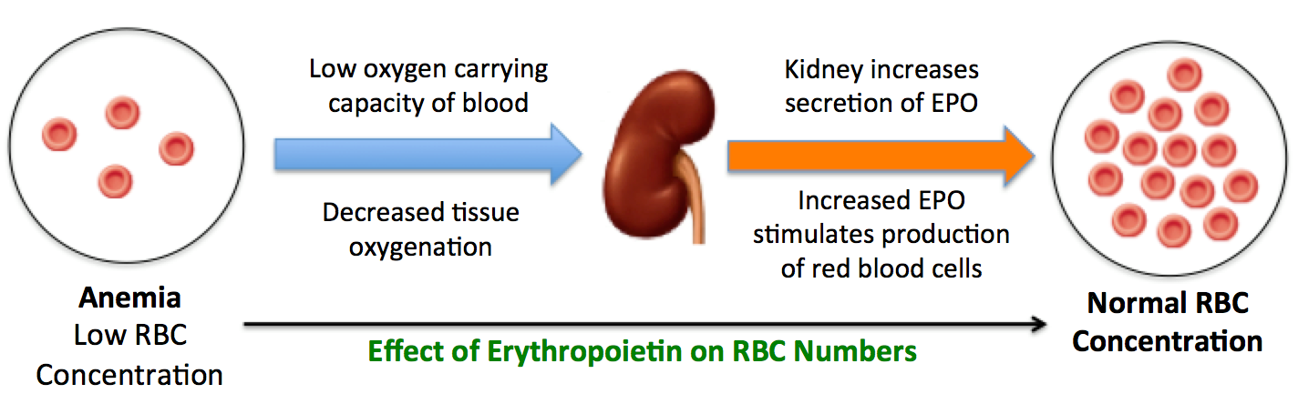  Figure 3. Effect of Erythropoietin (EPO) on red blood cell (RBC) numbers  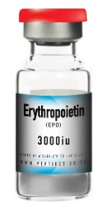  (EPO) is a hormone that regulates the production of red blood cells. EPO is produced by kidney cells, and can be deficient in individuals with chronic kidney diseases, resulting in reduced production of red blood cells, thus anemia.  EPO is made in response to low oxygen levels in the tissues. It signals the bone marrow to produce more red blood cells, which helps to increase oxygen delivery to tissues. EPO is also used as a doping agent in endurance sports because it can improve performance by increasing the amount of oxygen that is delivered to muscles. EPO doping has been reported to have negative health effects, including an increased risk of heart attack and stroke.  e) Work in pairs: In Figure 4 „Manipulations to enhance oxygen transport“ you find different ways of manipulating oxygen transport in the body. Create an easily interpretable table containing: method, short description including a graphic (you can use the ones from below), short summary of risks / health consequences, examples of people disgraced through using this method.  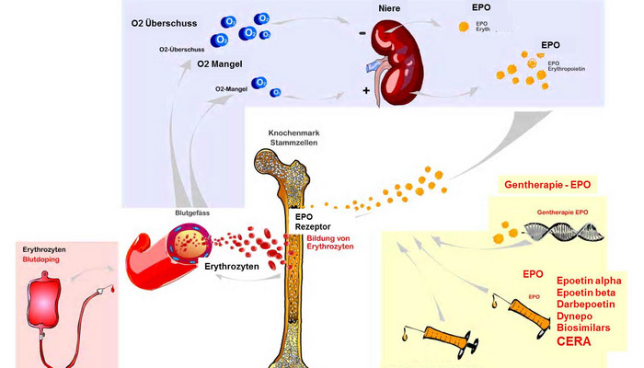  Figure 4. Manipulations to enhance oxygen transport. | 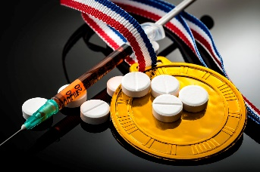  PA!  PA!  G4!  PA!  PA!  PA!  EA!  PA!  PA!
5)Creative tasks: Choose one of the following activities  a) Work in groups of 3 and create a crossword, Kahoot, word search, anti-doping song or any other fun activity to wrap up the topic Doping.  b) Work in pairs: What would be your anti-doping slogan on a T-shirt? Create a slogan and/or a graphic that shows your opinion on the topic of doping. This message will be printed on a T-shirt. Present your design to the class. Describe the background and thoughts behind your slogan and/or graphic.  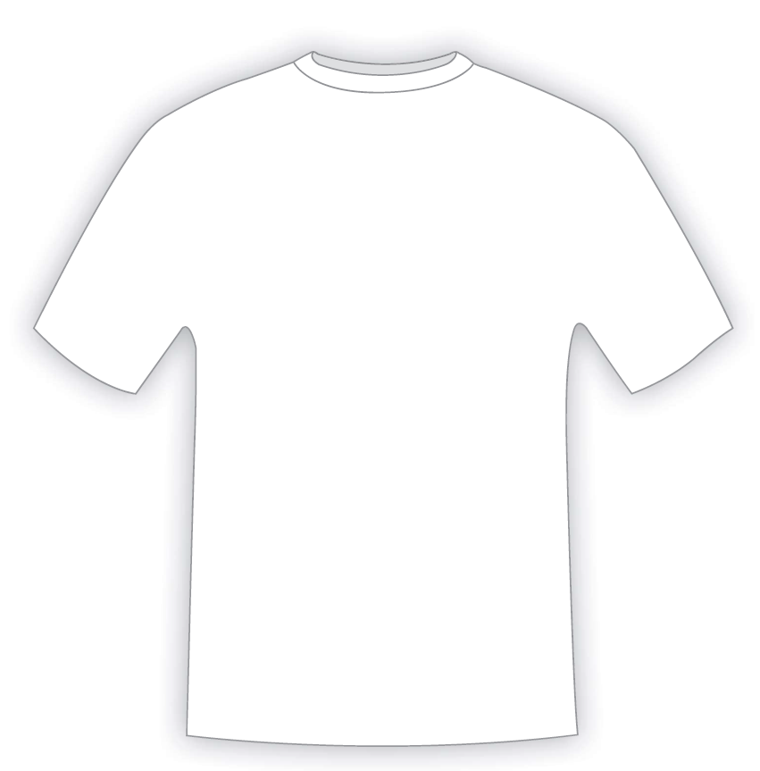  Back  Front  c) Work in groups of 3 and create a mood board:  A mood board is a type of collage made up of various images, colours and statements reflecting your mood on a topic. In addition to pictures and their arrangement, colours and shapes are important elements since they evoke a certain mood in the viewers.  Create your own mood board on sports & doping and think about the following aspects:  - Which aspect of doping would you like to focus on?  - What mood would you like to create?  - What colours, graphs, pictures etc.do you need to visualize the mood you’d like to convey?  You can create a poster or use Canva/ any other AI tool for your mood boards. Bring your (printed) posters to class as we’re going to do a gallery walk. | G3?  PA?  G3?

