Lesson Plan – Market Segmentation
(3 UE)

Topic | Clil Prompts | Follow-up | Time
Introduction – Make a guess! | Speculating Language |  | 5‘
Market Segmentation – Teacher Input |  |  | 20‘
 | Scanning for Comprehension – Clilstore „Market Segmentation“ Text;  Task „Market Segmentation Poster“ (+ Presentation) |  | 25‘
 |  | Guessing Game in Class – What segmentation criterion is it? | 10‘
 | Revision of Key terms of Market Segmentation – Pair-Exercise (Dice) |  | 15‘
 | Vocabulary-Training – learningapps.com (Homework)
Buyer Persona – Video + Explanation |  |  | 25‘
 | Task „Parent Persona“ – Teamwork + Presentation |  | 50‘

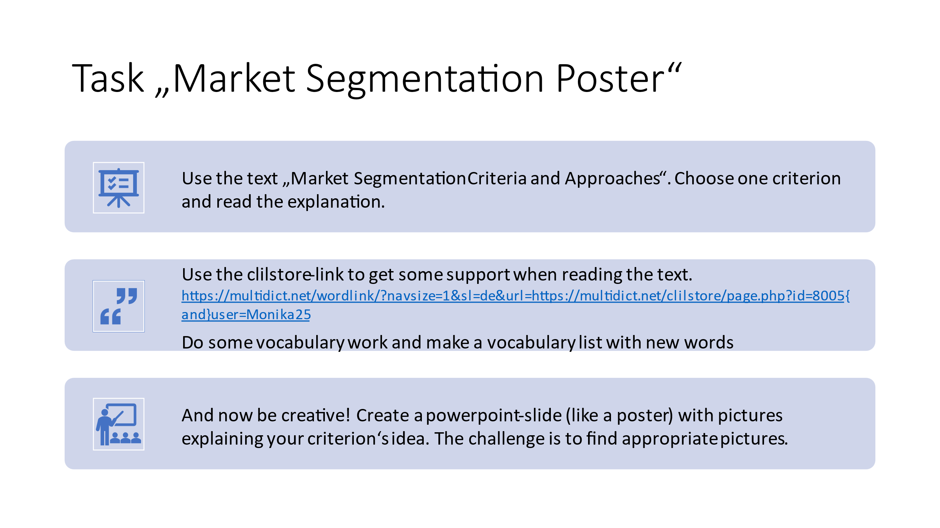

Guessing Game:

Present your slide and let the other students guess which segmentation criterion is displayed!

Segmentation Criteria and Approaches

Common Approaches to Market Segmentation
Segmentation starts by identifying all the potential buyers for your product: individuals with the need and the means to buy what you offer. In most cases, this represents a large universe of people or organizations that are similar in some ways but different in many other ways. Segmentation is a process that helps marketers narrow their focus on the most promising groups within that universe.
There is no single correct way to segment a market. Defining a target consumer base can be performed using a variety of segmentation methods. Several common methods are discussed below. Marketers may apply a combination of these methods to provide greater insight into their target market and the customers they want to serve. In fact, good marketers generally try out different methods and combinations to figure out what approach is most successful to help them achieve their goals. Because people and their needs change, effective approaches for segmenting a market can also evolve over time.

Geographic Segmentation
Geographic criteria—nations, states, regions, countries, cities, neighborhoods, or zip codes–define geographic market segments. Geography represents the oldest basis for segmentation. Regional differences in consumer tastes for products are well known, such as the affinity for barbecue in the southern U.S. or preferences for health-conscious menus in coastal California. Geographic segmentation suggests that in areas prone to rain, for instance, you can sell things like raincoats, umbrellas, and rubber boots. In hot regions, you can sell summer wear; in cold regions, you can sell warm clothes.
Geographic markets are easily identified, and large amounts of data are usually available. Many companies simply do not have the resources to expand beyond local or regional areas, so they must focus on one geographic segment only. There is very little waste in the marketing effort, in that the product and supporting activities such as advertising, physical distribution, and repair can all be directed at the customer. Further, geography provides a convenient organizational framework.
The drawbacks of using a geographic basis for segmentation are also worth noting. There is always the possibility that consumer preferences aren’t dictated by location—other factors, such as ethnic origin or income, may be more important. The stereotypical Texan, for example, is hard to find in Houston, where one-third of the population has immigrated from other states. Another problem is that geographic areas can be defined as very large, regional locations. Members of a geographic segment may be too heterogeneous to qualify as a meaningful target market.

Demographic Segmentation
Demographics are statistical data that describe various characteristics of a population. Demographic segmentation consists of dividing the market into groups based on demographic variables such as age, gender, family size, income, occupation, education, religion, ethnicity, and nationality. Demographic segmentation variables are among the most popular bases for segmenting customer groups because demographic data are plentiful and customer wants and needs often link closely to these variables.

For example, the youth market (roughly ages five to thirteen) not only influences how their parents spend money, but also how they make purchases of their own. Manufacturers of products such as toys, records, snack foods, and video games have designed promotional efforts directed at this group. “Tweens” are children between the ages of eight and twelve who are discovering what it means to be a consumer and are shaping the attitudes and brand perceptions they will carry with them as they grow up and gain more purchasing power. The elderly market (age sixty-five and over) has grown in importance for producers of products such as low-cost housing, cruises, hobbies, and health care.

Life stage is another demographic trait associated with age, gender, marital, and family status. There is evidence that individuals and families go through predictable behavioural patterns associated with buying behaviours. For example, a young couple with one young child has far different purchasing needs than empty-nesters in their late fifties or single, middle-aged professionals.^{[1]}

Income is perhaps the most common demographic basis for segmenting a market because it indicates who can or cannot afford a particular product. It is quite reasonable, for example, to assume that individuals earning minimum wage could not easily purchase a $80,000 sports car. Income is particularly useful as a segmentation input as the price tag for a product increases. It can also be helpful in understanding certain types of buying behaviour, such which income groups are most prone to use coupons.
Similarly, other demographic characteristics can influence other types of consumer activities.

Despite the apparent advantages of demographic segmentation (i.e., low cost and ease of implementation), uncertainty exists about its effectiveness. The method can be misused. For example, it might be said that the typical consumer of Thai food is under thirty-five years of age, has a college education, earns more than $10,000 a year, lives in a suburban fringe of a moderate-size urban community, and resides in the West. While these characteristics may describe a typical consumer of Thai food, they also describe many other consumers and may paint an overly broad or inaccurate portrait of a supposed “segment.” When a segment is too broad, it loses its defining characteristics and there isn’t much to differentiate the target segment from the general population. In this situation, the segmentation approach does not provide much useful guidance to help marketers make effective marketing choices.

Psychographic Segmentation
In psychographic segmentation, consumers are divided according to common characteristics in their lifestyle, personality, attitudes, and social class. Evidence suggests that attitudes of prospective buyers toward certain products influence their subsequent purchase or non-purchase of them. If persons with similar attitudes can be isolated, they represent an important psychological segment. Attitudes can be defined as predispositions to behave in certain ways in response to given stimulus.^{[2]}

For market segmentation purposes, personality is defined as long-lasting characteristics and behaviours of a person that shape how they cope and respond to their environment. Consumption of particular products or brands relates to consumer personality. For example, risk-seeking individuals are attracted to extreme sports and travel, and extroverts tend to dress conspicuously.
Social class segmentation identifies individuals based on a combination of socioeconomic such as education, occupation, income, family background, and attitudes related to these factors.

Lifestyle segmentation refers to the orientation that an individual or a group has toward consuming products, work, and play and can be defined as a pattern of attitudes, interests, and opinions held by a person. Lifestyle segmentation has become very popular with marketers, because of the availability of consumer data, measurement devices and instruments, and the intuitive categories that result from this process.[3] As a result, producers target versions of their products and their promotions to various lifestyle segments. For example, U.S. companies like All State Insurance are designing special programs for the good driver, who has been extensively characterized through a lifestyle segmentation approach.[4]

Lifestyle analysis generally begins by asking questions about the consumer’s activities, interests, and opinions. If a woman earns $100,000–$150,000 per year as an executive, is married and has two children, what does she think of her roles as a professional, a wife, and a mother? How does she spend her spare time? To what groups does she belong? What does she read? How does she use electronic devices? What brands does she prefer, and why? AIO (activities, interests, opinions) inventories, as they are called, reveal vast amounts of information concerning attitudes toward product categories, brands within product categories, and user and non-user characteristics.
Overall, psychographic segmentation tends to focus on how people spend their money; their patterns of work and leisure; their major interests; and their opinions of social and political issues, institutions, and themselves. While it can create intuitive groupings and useful insights into consumer behaviour, it can also take significant research and effort to inform a more complex and nuanced approach to defining market segments.

Behavioural Segmentation
Consumers are divided into groups according to common behaviours they share. Typically these behaviours link to their knowledge of, attitude toward, use of, or response to a product.
The most common type of behavioural segmentation is around user segments. In 1964, the market researcher Twedt made one of the earliest departures from demographic segmentation when he suggested that the heavy user, or frequent consumer, was an important basis for segmentation. He proposed that consumption of a product should be measured directly to determine usage levels, and that promotion should be aimed directly at the heavy user. This approach has since become very popular. Considerable research has been conducted on “heavy users” of a variety of products. The results suggest that finding other characteristics that correlate with usage rate often greatly enhances marketing efforts.^{[5]}

Other behavioural bases for market segmentation include the following:

- User status: Looking beyond “heavy users,” it can also be helpful to identify segments based on a broader set of use patterns, such as non-users versus ex-users, or one-time users versus regular users. Mobile phone service providers examine usage patterns to create optimal plans and targeting based on specific sets of user needs: family plans, individual plans, no contract plans, unlimited talk and data plans, and so forth. New car producers have become very sensitive to the need to provide new car buyers with a great deal of supportive information after the sale in order to minimize unhappiness after the purchase.

- Purchase occasion: This approach tries to determine the reason or occasion for purchasing a product and how it will be used. For example, airlines typically segment customers based on the reason for a passenger’s trip: business versus personal travel. Someone traveling for business generally has different needs and wants from someone traveling for pleasure. A business traveller tends to be less sensitive about price and more focused on timing, location, and convenience.
- Loyalty: This approach places consumers in loyalty categories based on their purchase patterns of particular brands. A key category is the brand-loyal consumer. Companies have assumed that if they can identify individuals who are brand loyal to their brand, and then delineate other characteristics these people have in common, they will locate the ideal target market. There is still a great deal of uncertainty about the most reliable way of measuring brand loyalty.
- Readiness: Readiness segmentation proposes that potential customers can be segmented according to how ready they are to purchase a product: unaware, aware, informed, interested, desirous, and intend to buy. Using this approach, a marketing manager can design the appropriate market strategy to move them through the various stages of readiness. These stages of readiness are rather vague and difficult to measure accurately, but readiness may be a useful lens for understanding the customer’s mindset and how to nudge them toward buying, particularly when an education process is required prior to purchase.

Decision-Maker Segmentation
This segmentation approach groups people according to who makes the purchasing decision in an organization or household. Typically there is a “primary buyer”: the individual who makes the final decision about what to buy and allocates the budget for the purchase. Many purchasing decisions also involve “influencers.” These are people who do not make the final purchasing decision, but they can influence the final choice about what to buy.
In families, for example, young children may be influencers in whether a parent buys Cheerios, Chex, or Fruit Loops. In companies, a department manager may be the primary buyer for a software product, but that manager’s work team may influence product selection by helping evaluate options to determine which choice best fits their needs. Segmentation by decision-making role helps marketers understand who truly matters in the purchase process and home in on the individuals who matter most.

Segmenting Business-to-Business Markets
All of the segmentation approaches above apply to consumer markets. There are many similarities between consumer and business behaviour, and therefore similar segmentation bases and variables apply. Common business segmentation approaches include:
- Organization size: segmentation according to large, medium, and small customers by revenue, by number of employees, by geographic reach, etc.
- Geography: organizing segments based on geographic location
- Industry: segmenting by the industrial sector an organization operates within—for example manufacturing, retail, hospitality, education, technology, health care, government, professional services, and so forth
- User status: usage frequency, volume used, loyalty, longevity, products already in use, readiness to buy, etc. For example, longtime loyal customers with “strategic” relationships are often handled differently and receive preferable terms compared to newer customers.
- Benefits sought: grouping customers by common elements they look for in a product or purchasing experience
- End use: identifying segments based on how they plan to use the product and where it fits into their operations and supply chain. For example, an electric motor manufacturer learned that customers operated motors at different speeds. After making field visits and confirming these uses, he thought to divide the market into slow-speed and high speed segments. In the slow-speed segment, the manufacturer emphasized a competitively priced product with a maintenance advantage, while in the high-speed market product, superiority was stressed.
- Purchasing approaches: organizing the market according to the way in which organizations prefer to make purchases; those preferences, in turn, determine how the seller builds the relationship with the customer and works the deal.

Use the following link, if you need support for vocabulary:
https://multidict.net/wordlink/?navsize=1&sl=de&url=https://multidict.net/clilstore/page.php?id=8005{and}user=Monika25

(Source: https://www.coursesidekick.com/marketing/study-guides/wmopen-principlesofmarketing/common-segmentation-approaches)

William "R. Darden, W.A. French, and R.D. Howell, \"Mapping Market Mobility: Psychographic Profiles and Media Exposure,\" Journal of Business Research, Vol. 7, No.8, 1979, pp. 51-74." ↵
Martha "Farnsworth, \"Psychographies for the 1990s,\" American Demographics, July 1989, pp. 25, 28-30." ↵
William "D. Wells, \"Psychographies: A Critical Review,\" Journal 0f Marketing Research, May 1975, pp. 196-213." ↵
Joseph "T. Plummer, \"The Concept and Application of LifeStyle Segmentation,\" Journal of Marketing, January 1974, p. 33. David J. Reibstein, Christopher H. Lovelock, and Ricardo de P. Dobson, \"The Direction of Causality Between Perceptions, Affect, and Behavior: An Application to Travel Behavior,\" Journal of Consumer Research, Vol 6., March 1980, pp. 370-376." ↵
Ronald "J. Frank, William Massey, and Yoram Wind, Market Segmentation, Englewood Cliffs, N.J.:Prentice-Hall, 1972. II." ↵
William "R. Darden, W.A. French, and R.D. Howell, \"Mapping Market Mobility: Psychographic Profiles and Media Exposure,\" Journal of Business Research, Vol. 7, No.8, 1979, pp. 51-74." ↵
Martha "Farnsworth, \"Psychographies for the 1990s,\" American Demographics, July 1989, pp. 25, 28-30." ↵
William "D. Wells, \"Psychographies: A Critical Review,\" Journal 0f Marketing Research, May 1975, pp. 196-213." ↵
Joseph "T. Plummer, \"The Concept and Application of LifeStyle Segmentation,\" Journal of Marketing, January 1974, p. 33. David J. Reibstein, Christopher H. Lovelock, and Ricardo de P. Dobson, \"The Direction of Causality Between Perceptions, Affect, and Behavior: An Application to Travel Behavior,\" Journal of Consumer Research, Vol 6., March 1980, pp. 370-376." ↵
Ronald "J. Frank, William Massey, and Yoram Wind, Market Segmentation, Englewood Cliffs, N.J.:Prentice-Hall, 1972. II." ↵

Licenses and Attributions
CC licensed content, Shared previously
Criteria for Segmentation. From Marketing 2014. Provided by: Boundless. Located at: https://www.coursehero.com/study-guides/boundless-marketing/. License: CC BY-SA: Attribution-ShareAlike
Introducing Marketing, Chapter 2: Understanding and Approaching the Market. Authored by: John Burnett. Provided by: Global Text. Located at: http://solr.bccampus.ca:8001/bcc/file/ddbe3343-9796-4801-a0cb-7af7b02e3191/1/Core%20Concepts%20of%20Marketing.pdf. License: CC BY: Attribution
Windsurfing at Gislu00f6vshammar. Authored by: Matthias Weinberger. Located at: https://www.flickr.com/photos/infomastern/10271441954/. License: CC BY-SA: Attribution-ShareAlike
Business Travel Panama. Provided by: thinkpanama. Located at: https://www.flickr.com/photos/23065375@N05/2247355466/. License: CC BY-NC: Attribution-NonCommercial
Sophie shopping. Authored by: David Veksler. Located at: https://www.flickr.com/photos/heroiclife/15316262230/. License: CC BY-SA: Attribution-ShareAlike
Dove Men+Care Asks: Is your hair ready for anything?. Provided by: DoveMenCare Philippines. License: All Rights Reserved. License terms: Standard YouTube License
CC licensed content, Specific attribution
What's today's choice. Authored by: Moshen Ben Cheikh. Provided by: Unsplash. License: CC0: No Rights Reserved. License terms: Unsplash License

